
United International University (UIU)
Dept. of Computer Science & Engineering (CSE)

Final Exam, Trimester: Fall 2024
Course Code: CSE-1115, Course Title: Object Oriented Programming
Total Marks: 40, Duration: 2 hours
Any examinee found adopting unfair means will be expelled from the trimester / program as per UIU disciplinary rules.

- Write the class D, where class D is a non-abstract class.
[5]
interface A{  int a();  int b();  }  interface B extends A{  int x();  int y();  } | abstract class C implements B{  public abstract void p();  }  public class D extends C{  // Write your code here  }

Note that
a() calculates u + v.
b() calculates multiplication of u×v.
x() calculates remainder, where u is the dividend and v is the divisor.
x() calculates $u^{v}$.
p() executes all the above methods and displays the calculated results.
Use necessary field variables and set methods. Make a main method and display all the results using u = 4, v = 10.

- Write the InvalidAgeException class, which extends the Exception class and invoke the parent class constructor. [5]
public class UIU {  public static void validate(int age) throws InvalidAgeException {  if (age < 18) {  throw new InvalidAgeException("Age must be 18 or above");  }  System.out.println("Valid age: " + age);  } | public static void main(String[] args) {  try {  validate(12);  } catch (InvalidAgeException e) {  System.out.println("Caught  Exception: " + e.getMessage());  }  }  }

- Write a Java program to read a user-define string from keyboard and write it into a file. [5]
public class Q3{
public static void main(String[] args) {
File myFile = new File("myText.txt");
try{
// read a line as String from keyboard;
// write the input String into the file: myText.txt;
in.close();
out.close();
}catch(IOException e){
System.out.println(e);
}
}
}

- Suppose you have a file “id.txt” that contains the ids of multiple UIU students. Write a java code to write the odd ids in the id.txt file to another file called “odd.txt” and the even ids in the id.txt file to another file called “even.txt”.
[10]

Check the following example for clarification:
id.txt | odd.txt | even.txt
011001212  011002213  011003214  011004215  011005216 | 011002213  011004215 | 011001212  011003214  011005216

- Write the Java code for the following GUI application that has the functionally of converting Foot to Inch (Formula: 1 foot = 12 inch). Foot will be converted to Inch after pressing the Convert button. [10]

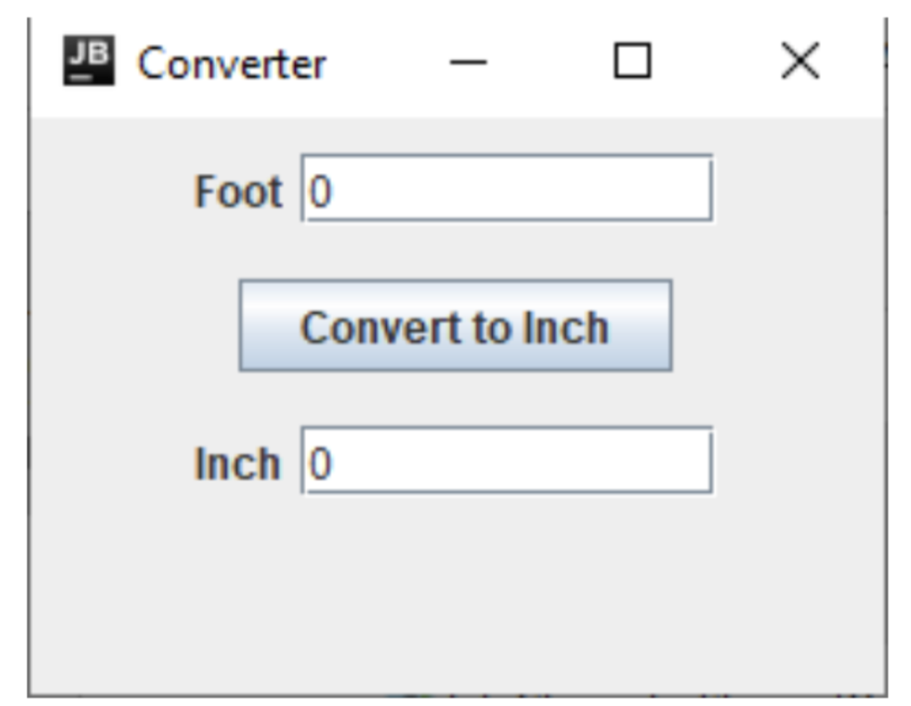

- Write a Java program to evaluate z given as
$$z=1-\frac{x}{2}+\frac{x^{2}}{3}-\frac{x^{3}}{4}+\frac{x^{4}}{5} …+\frac{x^{50}}{51}$$

using two threads. One thread will handle the addition of negative parts, while the other will handle the addition of positive parts. The final result should be computed by combining the results from both threads, using x = 1.15.
[5]

